Spring Bank Primary School

Email: hello@springbankprimary.org
Website: www.springbankprimary.org
Spring Road, Leeds LS6 1AD
Tel 204 3120 Fax 204 3121

Friday 9th February

Dear Parents/Carers,

We’re at the end of another half-term and we managed to come out rather unscathed by the snow. After the break, you’ll be pleased to hear that the clubs will be back in full-flow. The days and times can be found below. We wish you all have a lovely break next week as we thank the staff for their hard work, especially on these dark, winter days.

Celebration Assemblies

Today, our new format for assemblies took place. Thank you parents/carers for keeping it a secret! A huge congratulations to the following pupils who received a certificate:

- Reception – Farwah & Iris
- Year 1 – Simona & Zhuoyi
- Year 2 – Savanna & Sereen
- Year 3 – Andrea & Elsa
- Year 4 – Keir & Lucy
- Year 5 – Melissa & Nethuli
- Year 6 – Laurie & Paniz

Clubs
The schedule for PE after school clubs next half-term are as follows. Mr Wrankmore and Miss Houldsworth has explained that the children who were previously in these clubs have automatically been added to the registers. If you would like your child/children to take part in these clubs, please get in touch with the office.
- Monday: Girls Football Club - Pitch (Mr Wrankmore & Miss Casey)
- Tuesday: Year 3/4 Football Club - Pitch (Matt Garman)
- Wednesday: KS2 History Club – (Nesta Holden)
- Wednesday: Dance Club - Hall (Nicola Booth - Leeds Rhinos)
- Wednesday: Samba club – Mr Gideon Woods
- Thursday: Netball Club - Hall/Pitch (Nicola Forwood)
- Friday: Year 5/6 Football Club - Pitch (Mr Wrankmore)
The following clubs will be starting after half-term. Please use Parentmail to book your children onto the clubs:

- Monday: (Starting on Monday 26th Feb) KS1 Music - Lorraine
- Wednesday: (Starting on 28th Feb) Y6 cooking club - Miss Houldsworth & Helena

All of the above school clubs run from 3:30-4:30 apart from Dance Club which finishes at 4:25.

Lunchtime clubs are also continuing with Drama, Choir and Chess.

Staffing update
We would like to let you know that Mrs Ryan will not be returning to Spring Bank Primary. Mrs Ryan was a dedicated EYFS class teacher and SENDCo for the school and was a huge part of our school community, we wish her every success in all she endeavours.
We would like to thank Tracy Myers in Year 1 for completing her teaching placement with since September. The children have built a lovely rapport with her and she will be missed dearly by staff and pupils alike. We wish her the very best throughout her duration of her teacher training and future career.

Miss Birk-Telford has a busy half-term coming up. Spring Bank Primary wishes her the loveliest of days on Monday when she has her wedding and returns as Mrs Tomlinson. Have a lovely honeymoon!

Attendance

Despite the 100 day cough and other illnesses lingering, our attendance has increased since last week. Well done to Year 6 for managing an impressive 98%.

World Book day
Thank you, Mrs Ward, for organising Spring Bank’s World Book day this year. A reminder that KS1 will have a visit from an author on 5th March and KS2 pupils will meet an author on 7th March, which is the same day as World Book Day. Feel free to come dressed-to-impress as lots of pictures will be taken and a new school display will be made. We are asking for a £5 donation too, which is made payable on Parentmail to cover the cost of the experience.

Pizza Express

Reception had their first trip on Tuesday morning. We walked to Pizza Express where we made our own pizzas. The children had a great time kneading the dough and spreading it out as well as adding the tomato sauce and cheese. We took our pizzas back to school and enjoyed eating them at lunchtime. It was a fantastic trip! We’d also like to thank our volunteers who assisted on our trip out. Without you, these experiences would be very difficult to plan and carry out. Miss Birk-Telford.

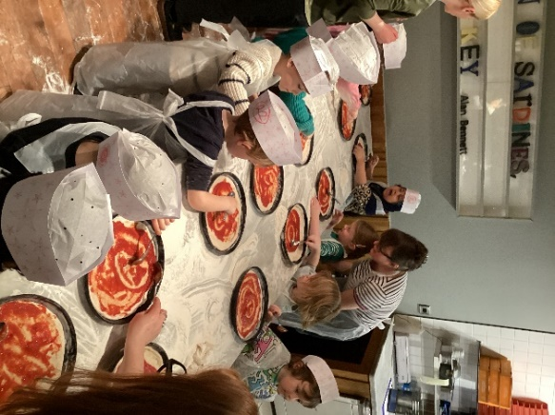
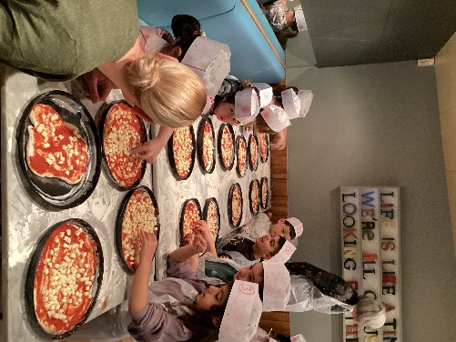

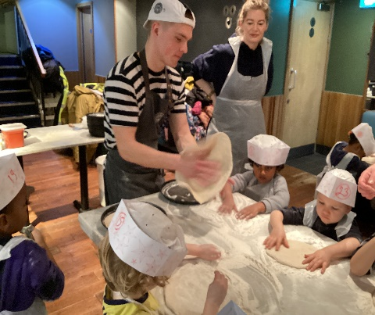
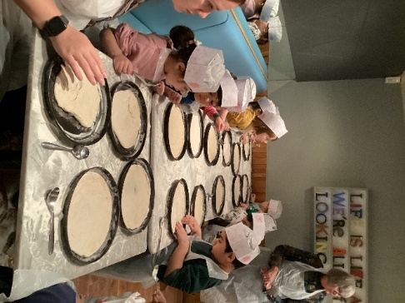

PTA
On Monday evening, we had our first PTA meeting in 2024. We have a number of diary dates for you with further information to follow after half-term.

- KS1 Movie night – 29th February
- KS2 Movie night – 7th March
- KS1 disco – 6th June
- KS2 disco – 6th June
- Summer Fair – 6th July

Many of you will know that to keep our PTA fund topped up, we run a tuck-shop after school on Thursdays. We’d love to have an extra volunteer or two every other week. Please pop into the office if you think you can help with this.

Our next PTA meeting will be on 22nd April. We hope you can make it.
Ursula Philpot and Jordan License

We hope you have a lovely half-term holiday.

Jordan License
Head of School

DATES FOR THE DIARY
Training Days for this year
Monday 3rd June 2024

Key dates
- Return to school - Monday 19th February
- KS1 Movie night – 29th February
- 4th - 8th March - STEM week
- 5th March - KS1 Author visit
- 7th March - KS2 Author visit
- 7th March - World Book Day
- KS2 Movie night – 7th March
- 13th and 14th March - Parents' Evening
- KS1 disco – 6th June
- KS2 disco – 6th June
- Summer Fair – 6th July

